Emergency Action Plan (example)

Emergency numbers: | 9-1-1 ~ If not, local police, fire, ambulance numbers should be posted
Contact Information | President: Jim Brown | Cell: 613-555-1212
 | Manager: Jane Smith | Cell: 613-555-1234
 | Ice Tech: John White | Cell: 613-555-1256
 | Other: Sue Jones (bar manager) | Cell: 613-555-1278
Curling Rink Information  Ottawa Curling Club | Address:  440 O’Connor Street,  Ottawa, ON K2P 1W4  Telephone:  613.234-4119  Nearest cross street:  Catherine & the Queensway |  | 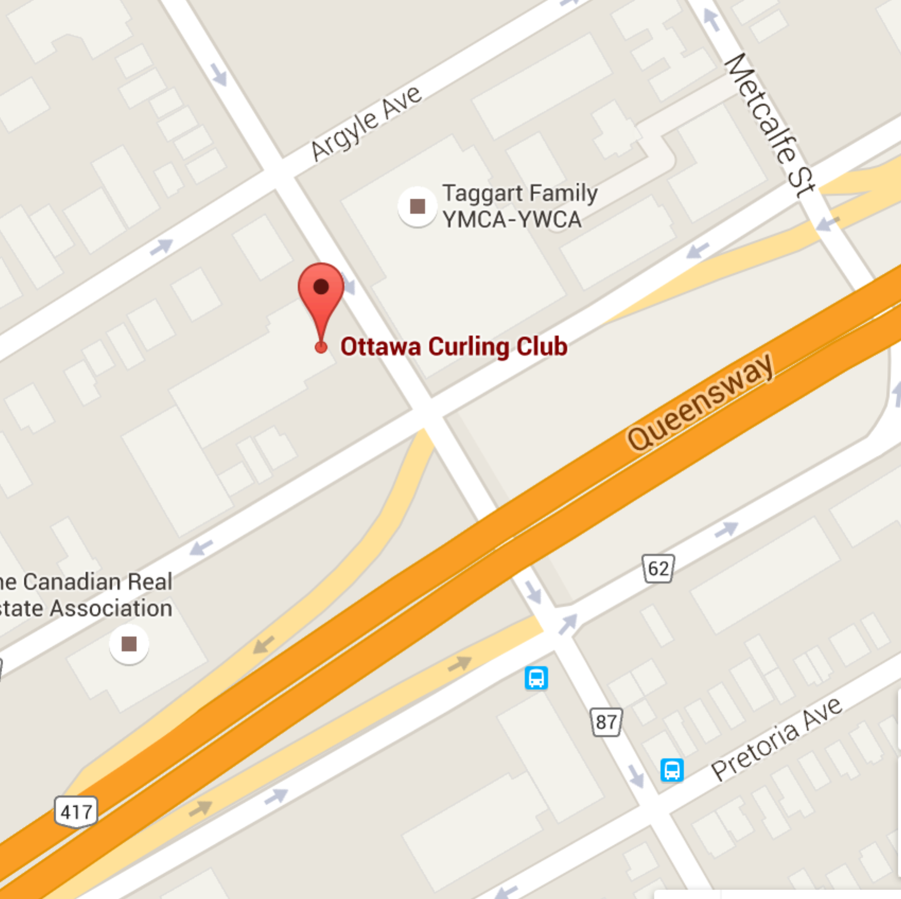
Person(s) on-site in charge  - Clear risk of further harm to the injured person by securing the area and shelter the injured person from the elements.  - Designate who is in charge of the other participants.  - Protect yourself (wear gloves if in contact with body fluids such as blood).  - Check that airway is clear, breathing is present, a pulse is present, and there is no major bleeding.  - Wait by the injured person until the ambulance arrives and the injured person is transported  - Fill in an accident report form |  |  | Names  Option 1: Steve Good  Option 2: Rick Shea  Option 3: Jennifer Smith
On-site Call Person(s)
- Call for emergency help.
- Provide all necessary information to dispatch (e.g. facility location, nature of injury, what, if any, first aid has been done).
- Clear any traffic from the entrance/access road before ambulance arrives.
- Wait by the driveway entrance to the facility to direct the ambulance when it arrives.
- Call the emergency contact person listed on the injured person’s medical profile.

