Learning to Train (8-12 y.o.)

Remember – the use of a helmet is always recommended for young curlers.

Program Focus: FUN, developing self-confidence, specific and general motor skills for curling, encouraging participation and cooperation with peers

On Ice Activities: Developing basic delivery and sweeping skills

Great Ideas:

- Stance, Start-up and Go!

Along the sideboards, have the Curlers assume the stance position with the heel of the “hack foot” (the gripper foot) positioned against the board. Then move them into the start-up position (rise to a semi-crouch position), followed by a push- forward, extending into the final slide position.

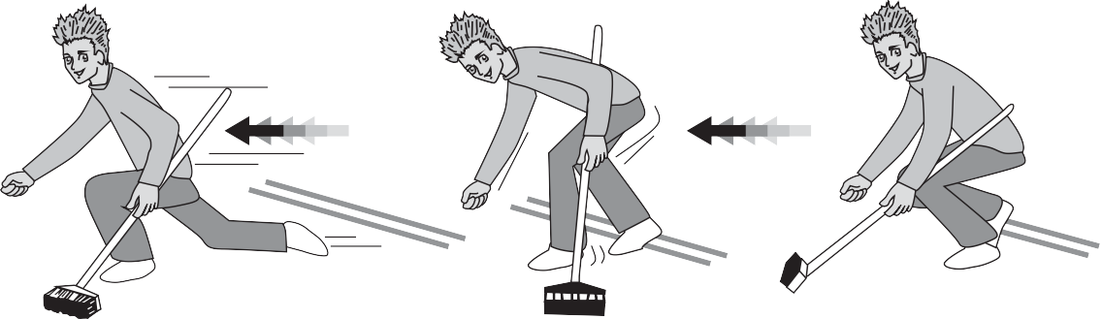

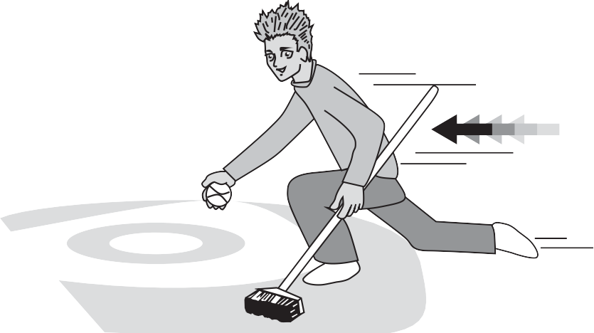
- Go, Slide and Glide!

Add a delivery object to the delivery progression. Start with a lighter weight object (i.e. an empty pop can, bean bag or puck), then move on to a curling stone or modified version of a stone (little rock).

Have the Curlers complete the forward slide with the delivery object in hand without releasing it. Just slide and glide!

- Directional Game - “Ice Bowl”

Objective: To practice line of delivery by using a curling stone (real or modified) to knock over target objects (i.e. plastic bottles, milk cartons, etc.).
Variation: Divide Curlers into teams and award points for bottles knocked down.
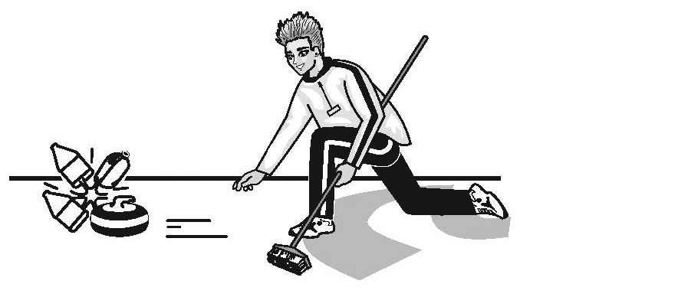

- On-Ice Brushing Progression
Brushing is an integral part of the sport for Curlers at all levels. When introducing children to brushing, begin with a simple explanation of why brushing is important and the effect it has on a moving curling stone. Then, emphasizing balance and safety use the following progression steps to introduce the brushing skills.

Step #1: Stance and Grip - Stationary
Have your Curlers assume the proper position to brush (stance and grip on the brush).

Step #2: Brushing on the Spot
Have the Curlers sweep without moving their feet.

Step #3: Footwork
Incorporate footwork, performing a cross-country ski-like shuffle to achieve forward movement while making the brushing motion.

Step #4: Throw and Brush
Introduce a curling stone (real or modified) to be brushed. Start by slowly pushing or guiding the stone for the brushers, then progress to letting the stone slide on its own, with the Curler brushing as it goes.
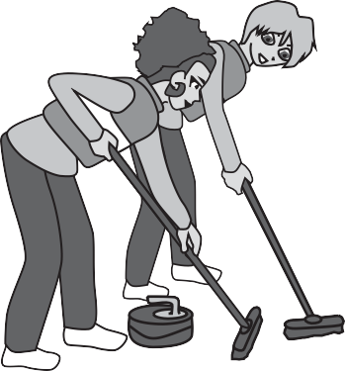
Step #5: Partner Brush
Introduce the Curlers to proper positioning and movement with a buddy, without a curling stone being used. Remember that there are two options for the positioning of brushing pairs (same side or opposite sides).

Step #6: Put it All Together
Once your Curlers are comfortable brushing with a partner, incorporate a delivery object into the brushing drills.

